CITIZEN AI-INTELLIGENT CITIZEN ENGAGEMENT PLATFORM

PROJECT DOCUMENTATION

**1.INTRODUCTION**

* PROJECT TITLE : CITIZEN AI-INTELLIGENT CITIZEN ENGAGEMENT PLATFORM
* TEAM MEMBER: N.NASREEN SHIFA(LEADER)
* TEAM MEMBER: P.VISHALINI
* TEAM MEMBER: S.SATHYA
* TEAM MEMBER: N.KODEESHWARI

**2.PROJECT OVERVIEW**

* PURPOSE: Citizen AI is a burgeoning concept that is unfolding in two significant yet distinct arenas: empowering non-technical users in the business world to become AI creators and revolutionizing how governments and public services interact with their citizens. At its core, Citizen AI is about democratizing artificial intelligence, making its power accessible to a broader audience beyond data scientists and engineers.
* FEATURES:

A conversational interface in Citizen AI enables citizens to interact with government services and platforms using natural language, either through text or voice. Key features include:

1. Chatbots: AI-powered virtual assistants that provide information and support.

2. Natural Language Processing (NLP): Understands citizen queries and responds accordingly.

3. Personalized Experience: Offers tailored responses and guidance.

4. 24/7 Availability: Citizens can access information and services at a home

5.Applications in Business & Enterprise

​Unlocking Business Potential: Citizen AI in the Corporate World

​The Role of Low-Code/No-Code Platforms in Empowering 6.Citizen Developers

​Use Case: Streamlining Workflows with Citizen-Built AI Solutions

​7.Navigating the Risks: Data Privacy and Security Concerns

​8.The Digital Divide: Ensuring Equitable Access to Citizen AI

​Governance and Oversight for Citizen-Led AI Development

​Mitigating Unintended Consequences of Citizen AI

​The Future of Citizen AI

​9.Future Trends: What's Next for Citizen AI?

​The Convergence of Citizen AI and Other Emerging Technologies

​10.Building a Future-Ready Workforce: The Importance of AI Literacy

​Projected Growth and Market Analysis of Citizen AI

**3.ARCHITECTURE**

Frontend/User Interface:

Citizen Portal (Web/Mobile)

Built using React, Vue, or Angular for accessibility and responsiveness—enables complaint submission, feedback, tracking, and interactive dashboards.

Example: CitizenAI's responsive UI with analytics dashboards, sentiment views, and issue tracking .

Backend/ User Interface layer:

The backend architecture of a Citizen AI intelligent citizen engagement platform serves as the core engine that powers all AI functionalities, data processing, and secure interactions between users and the system. It is designed to handle a wide range of tasks such as receiving citizen inputs (complaints, queries, suggestions), processing these through AI/ML models (for classification, sentiment analysis, urgency prediction), and routing them to the appropriate authorities or departments.

Example:

(PostgreSQL) or NoSQL (MongoDB) database, with support for audit logging and data versioning.

**4.Setup Instructions**

1.Install Python 3.9 or higher

2. Install Git

3. Install PostgreSQL and note the default username, password, and port

4. Ensure pip (Python package manager) is installed and updated

5. Install virtualenv using pip (optional but recommended)

6. Install Docker (optional, for containerization)

Installisation Process:

1. Get the backend project files.

2. Set up a virtual environment (optional).

3. Install required packages.

4. Configure environment variables

5. Create and prepare the database.

6. Run database migrations.

**5.Folder Structure**

1. /app – Main application code (API routes, business logic)

2. /app/models – Database models and schema definitions

3. /app/controllers – Logic to handle requests and response

4. /app/services – AI processing, external API integrations, utilities

5. /app/config – Configuration files and environment settings

6. /migrations – Database migration scripts

7. /tests – Unit and integration test files

8. /docs – Documentation files (API specs, README, etc.)

9. requirements.txt – Python dependencies list

10. Dockerfile – Container build instructions (optional)

11. docker-compose.yml – Multi-container orchestration (optional)

12. .env – Environment variable definitions (ignored in git)

**6.Running the Application**

* Set up the backend environment (virtual environment, dependencies, .env file).
* Start the database service (e.g., PostgreSQL).
* Apply database migrations to initialize tables.
* Run the backend server (Flask/FastAPI).
* Navigate to the frontend project folder.

**Frontend (Stream lit):**

To run the frontend of the Citizen AI Intelligent Citizen Engagement Platform, first navigate to the frontend project directory on your local machine.

**Backend (Fast API):**

To run the backend of the Citizen AI Intelligent Citizen Engagement Platform, start by ensuring all prerequisites are installed, including Python, pip, and a database like PostgreSQL.

**7.API Documentation**

Authentication APIs

* POST /api/auth/login – Login with email and password
* POST /api/auth/register – Register a new citizen
* POST /api/auth/logout – Logout the user
* GET /api/auth/me – Get current logged-in user's profile

**8.Authentication**

1. User Registration

Allows new citizens to create an account using name, email, and password.

2. User Login

Users log in using their email and password to receive a secure token (JWT).

3. Token-Based Authentication

After login, a JWT (JSON Web Token) is issued for accessing protected routes.

4. User Logout

Option to invalidate or remove the token on logout (handled on frontend or server-side blacklist).

5. Get Logged-In User Profile

Authenticated users can fetch their own profile information.

6. Role-Based Access Control (RBAC)

Supports different roles like Citizen, Admin, and Staff for secure access to features.

**9.User Interface**

1. Clean and intuitive dashboard for easy navigation.

2. Responsive design for desktop, tablet, and mobile use.

3. Simple complaint submission form with category, description, location, and attachments.

4. Real-time notifications for complaint updates

5. AI-powered chatbot for assistance and FAQs.

6. Search and filter options for complaints and reports.

7. Visual analytics with graphs and maps for data transparency.

8. Multilingual support for diverse user groups.

9. User profile management for citizens to view and update information.

10. Secure login and authentication interface.

**10.Testing**

1. Unit Testing

Test individual backend functions, AI modules, and frontend components separately.

2. Integration Testing

Ensure backend APIs and frontend communicate correctly and data flows seamlessly.

3. End-to-End (E2E) Testing

Simulate real user scenarios, like login, complaint submission, and status tracking.

4. Performance Testing

Check the system’s response time and scalability under load, especially AI processing.

5. Security Testing

Validate authentication, authorization, data encryption, and vulnerability scanning.

6. Usability Testing

Gather user feedback on UI/UX for accessibility, ease of use, and navigation.

7. Regression Testing

Verify that new changes don’t break existing features.

8. Automated Testing

Use testing frameworks (e.g., Jest, Pytest, Selenium) to automate repetitive tests.

9. API Testing

Validate all API endpoints for correct responses, error handling, and data integrity.

10. Compatibility Testing

Ensure the platform works across different browsers, devices, and OS versions.

**11.Screenshots**

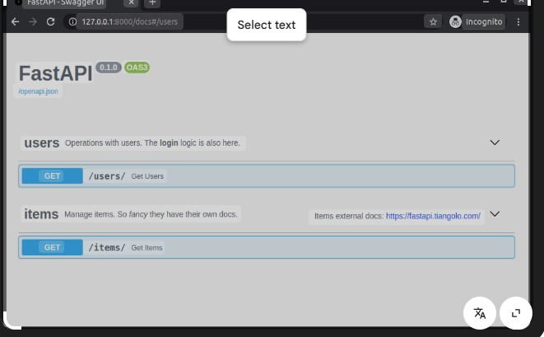

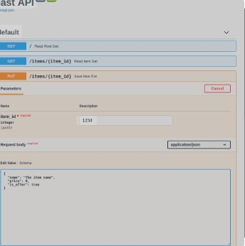

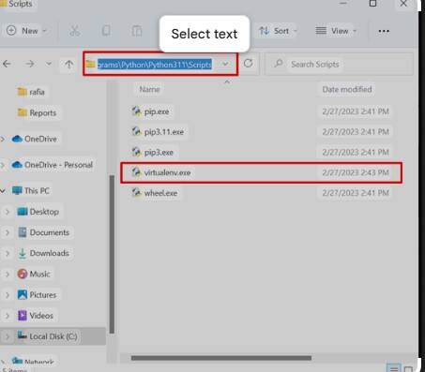

**12.known Issues**

1. Digital Divide & Access Inequality

Not all citizens have reliable internet, good devices, or sufficient digital literacy. Those in rural, low‑income or marginalized communities may be left out.

2. Bias & Algorithmic Discrimination

Datasets used to train AI often reflect historical inequities. AI may misinterpret or underrepresent voices of minorities, or favor those who are already better represented. This can reinforce existing social inequalities.

3. Transparency & Explainability

Many AI systems are “black boxes”—it’s hard for citizens (or even administrators) to see how decisions are made, what data is used, how priorities are set. This undermines trust.

4. Privacy, Data Security & Ethical Concerns

Handling sensitive citizen data comes with risks of misuse, leakage, surveillance, or over‑collection. Ensuring data is collected, stored, used, and destroyed in an ethical, legal manner is a big challenge.

5. Low Trust / Civic Apathy

If citizens feel that giving feedback or participating doesn’t lead to real change, or if AI decisions feel opaque or unfair, trust erodes. Citizens may disengage.

6. Superficial Engagement & Quantity over Quality

There’s a risk of measuring success by participation numbers rather than depth of engagement. Feedback can be shallow; responses may be simplistic to enable scalability rather than nuanced.

7. Scalability & Performance Problems

When used at city or national scale, platforms may struggle with real‑time response, handling thousands of concurrent users, integrating with legacy systems, etc.

8. Legacy Systems & Fragmented Services

Government / public sector often have many silos, different departments with incompatible processes or systems. An AI platform may find it hard to integrate, resulting in duplication, leakages, or inconsistent services.

9. Regulatory & Compliance Constraints

Laws around data protection (GDPR etc.), access rights, privacy, AI ethics are evolving. Ensuring compliance is nontrivial. Also, in many jurisdictions frameworks for AI accountability are still weak.

10. Human Oversight, Accountability

Because AI may make or support decisions that affect people, there needs to be human oversight. But sometimes, the lines of responsibility are unclear: who is accountable if the AI misclassifies, misprioritizes, or causes harm?

**13.Future Enhancement**

Enhancing citizen engagement with an AI-powered intelligence platform (such as a Smart City or GovTech system) requires a multi-dimensional approach that blends technology, accessibility, trust, and utility.

Here are future-focused enhancements to boost citizen engagement on such a platform:

1. Hyper-Personalized Citizen Dashboards

AI-driven insights tailored to each citizen (e.g., local events, service alerts, personal contributions).

Real-time feedback on how their reports (e.g., potholes, safety issues) are being addressed.

Integration with health, transport, and education services based on user preferences.

2. Explainable AI & Transparency Layer

AI systems should clearly explain decisions (e.g., “Why was this permit denied?”).

Trust-building through transparent data sources, audit trails, and AI logic.

3. Conversational Civic Assistants (Multilingual)

Deploy chatbots or voice assistants (like Siri/Alexa but civic-focused).

Support regional dialects/languages to reach underserved populations.

Integrated with local services: bill payments, application status, emergency help.

4. Two-Way Feedback & Co-Creation

Citizens not just reporting issues but co-creating solutions through AI-moderated forums.

AI detects trending community concerns and escalates them to authorities.

Gamified civic participation (badges, points for contributing ideas or voting).

​